EditGrid Excel Plus

Links 1
Installation 2
Using EditGrid Excel Plus (quick) 3
Warnings: 3
Quick use 3
1. In order to make a link between an Excel file on your PC and an online file on EditGrid 3
2. In order to alter an online EditGrid version using Excel on your local PC 3
Using EditGrid Excel Plus (detailed) 4
1. Connecting to EditGrid Server 4
1.1 Connects when MS Excel starts 4
1.2 Connects via Proxy Server 4
1.3 Reconnect to EditGrid Server 4
2. User login and logout 4
2.1 Personal Account 4
2.2 Organisational Account 4
2.3 Remember Me 4
2.4 Logout 5
3. Open Workbook 5
4. Save Workbook 5
5. Subscribe Worksheet 6
5.1 Subscribe 6
5.2 Unsubscribe 6
5.3 Limitations 6
6. Publish Worksheet 6
6.1 Establish Linkage between EditGrid and Excel 6
6.2 Publish Worksheets 6
7. Synchronize Region with EditGrid 7
7.1 Synchronise a selected region on Excel with EditGrid 7
7.2 Limitations 7
8. EditGrid File Browser 7
8.1 Open Public Workspace 7
8.2 After Logged in 8
8.3 Switching Workspaces 8
8.4 Navigating over spreadsheets and worksheets 8

__________________________________________________________________________________________________

Links
http://gerard.tayeb.free.fr/informatique/collaboratif.htm#EditGrid
http://www.editgrid.com/site/news/excel_plus_launch
http://www.cmswire.com/cms/enterprise-20/editgrid-excel-plus-kicks-google-spreadsheet-saas-001811.php

NOTE: the plugin is presently not working with the recent version Excel 2007
I use it with Excel 2003

Installation
Download the plugin from
http://www.editgrid.com/site/static/excel_plus/editgrid_excel_plus.exe

Double click on the file to install it
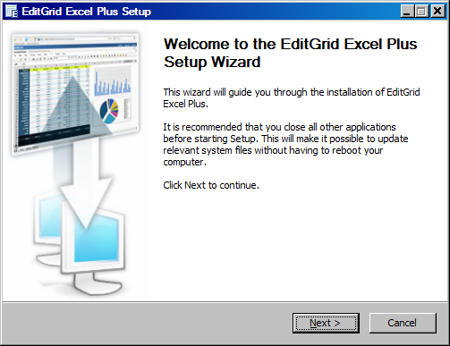

This will add a new menu to Excel. You will also get a new toolbar available:

Using EditGrid Excel Plus (quick)

Warnings:
Contrary to online edition on the EditGrid interface (where several users can modify the same spreadsheet simultaneously. The only condition is that they do not modify the same cell simultaneously), the use of EditGrid Excel Plus does not permit simultaneous editing. In fact, when you upload back online a spreadsheet, this version replaces the existing one on the EditGrid Server. It means that if somebody else has made some changes in between, these changes are lost (in fact, they can be retrieved using the "history" of all the versions changes of the file, which is automatically recorded by EditGrid).
Clearly, it means that the use of EditGrid Excel Plus requires that only one user should have the rights to alter the file. And the file should be preferably shared with read only rights for the other users.

Quick use
Start Excel

If you are connected to the internet, the leftmost icon will turn green.
Logon with the second icon (you can choose here that the application recalls your login, and further you will get automatically connected when you start Excel).

Now you have mainly two possibilities, depending whether you want to have the master file locally on your PC, or online on EditGrid.

1. In order to make a link between an Excel file on your PC and an online file on EditGrid
Use:
- If you are the only one to modify a spreadsheet and want to share it with others
- The master version will be the one on your local PC

I suppose that you have Excel 2003 (if not, the procedure differs)
1.01 Install the plugin EditGrid Excel Plus (if not already done)
1.02 Create a spreadsheet online (only the name of the spreadsheet matters; the file can be empty)
1.03 Open the local version of the spreadsheet (it will be the master one) with Excel
1.04 Click on "Publish Excel Worksheets"
1.05 A window appears. Click "Add Linkage"
1.06 Select the local worksheet that you want to link
1.07 Select the Worksheet URL using "Browse", and point towards the spreadsheet created in 1.02, then to the worksheet
1.08 Click "OK"
1.09 Another window appears, asking you to select the links that you want to publish. Select the worksheet that you just have linked, then click "Publish"
1.10 Click "Done"
1.11 Now you can edit the local file as any standard Excel file
1.12 The added feature is that each time that you click on "Publish Excel Worksheets", your local version will be uploaded on EditGrid and instantly available for all the other people sharing the worksheet

A funny way to follow what happens is to open two windows on your screen: one on EditGrid, and the other one on the local Excel
You will see the changes propagating from the local file to the online file automatically, when doing 1.12

2. In order to alter an online EditGrid version using Excel on your local PC
Use:
- If you are the only one to modify a spreadsheet and want to share it with others
- The master version will be the online one (on EditGrid server)

I suppose that you have Excel 2003 (if not, the procedure differs)
2.01 Install the plugin EditGrid Excel Plus (if not already done)
2.02 I suppose that you have already created the online spreadsheet on EditGrid
2.03 Open Excel
2.04 Click on "Open Workbook", and download the EditGrid file to your computer (select the file and click "Open")
2.05 Work on the file using Excel (at this stage, you work on a local copy of the online file)
2.06 When you want to upload your changes online, click to "Save Workbook"

Using EditGrid Excel Plus (detailed)
This section is copied from the help available in Excel menu, once the plugin has been installed

EditGrid Excel Plus is a plugin for Microsoft Excel™. You can now enrich your desktop spreadsheets with EditGrid's unique features.

1. Connecting to EditGrid Server

1.1 Connects when MS Excel starts
When you start Microsoft Excel, EditGrid Excel Plus automatically runs and connects to the EditGrid Server.
EditGrid Excel Plus will be disabled if it fails to connect to EditGrid server, in which, an orange status light will appear. Upon successful connection to EditGrid server, a green status light will appear.

1.2 Connects via Proxy Server
If your workstation is connecting to the internet via a proxy server, EditGrid Excel Plus will prompt for the username and password, so it can connect to the server through the proxy server.
You can check the box "Remember me" so that Excel Plus will save the given information and reuse it next time when proxy server authentication is required.

1.3 Reconnect to EditGrid Server
EditGrid Excel Plus will disconnect from server when the workstation is disconnected from the internet. Users have to manually reconnect to the EditGrid server by clicking on the orange status light in order to enable EditGrid Excel Plus

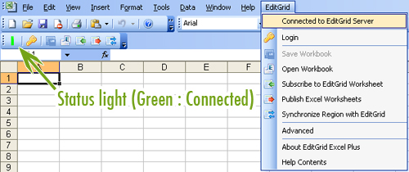

2. User login and logout

To access private spreadsheets under your workspace, you will have to login to your account. To login, click on the Key icon on the toolbar
Click on the key button to login

2.1 Personal Account
The login form has the classification set to Personal by default. Simply fill your username and password, and click "OK" to proceed.

2.2 Organisational Account
Select "Organisation Users" on the classification drop-down menu, and fill your username and password, then click "OK" to proceed.

2.3 Remember Me
There is a checkbox called "Remember my password". Check this box if you would like EditGrid Excel Plus to remember your login information, and automatically log you in whenever the plugin is started.
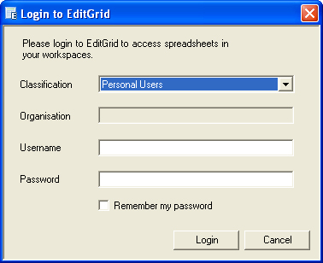
Login Form

2.4 Logout
After login, a logout icon will appear at the toolbar. Simply click on that icon to logout, and any private spreadsheets under your account will be no longer visible under MS Excel.
Click the door button to logout

3. Open Workbook

Open workbook allows you to open an EditGrid workbook in Excel. Changes made on the opened Excel workbook will not populate to EditGrid automatically, but you can save the changes by manually saving the workbook with the Save Workbook feature.
To open an EditGrid workbook, please follow the steps below:
- Click on the "Open Workbook" icon on the toolbar, or from the EditGrid menu
- Select a spreadsheet using the Open EditGrid file Browser. For more detail about the Open EditGrid File Browser, see here.
- Click "Open"

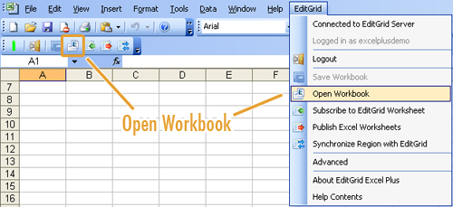

4. Save Workbook

Save workbook allows you to save an Excel workbook, which is an EditGrid workbook opened in Excel, back to EditGrid server. This feature is disabled if the current opened workbook is not opened by using the Open EditGrid Workbook feature.
Under the following conditions, user can upload workbook back to EditGrid server:
- User logged in and has permission to write content on the spreadsheet
- User not logged in and the spreadsheet is not password protected
Save workbook would override the content of that workbook on EditGrid, and the revision will be marked on the history, so users can revert the changes on EditGrid if needed.

5. Subscribe Worksheet

5.1 Subscribe
Subscribe worksheet allows users to subscribe an EditGrid worksheet and see its most updated changes on Excel. The subscribed worksheet gets real-time data feed from EditGrid server, so whenever data gets updated on EditGrid, those changes will be updated on the subscribed sheet on Excel as well
Note that the subscribed worksheet is protected on Excel, in other words, it's a Read-only worksheet in Excel. Data in subscribed worksheet is transferred one way from EditGrid to Excel only, so if worksheet is editable on Excel, data on the two copies might be the same.

5.2 Unsubscribe
To unsubscribe a worksheet, go to EditGrid > Advanced, then uncheck the corresponding mapping to temporarily unsubscribe. To subscribe again, simply check the checkbox. You can also delete the corresponding mapping to unsubscribe permanently.
Under the following situation, the subscribed worksheet will be unsubscribed automatically
- The subscribed worksheet was a public spreadsheet, and its owner changed its permission so it's no longer readable by the public
- You're a shared user, and you're not logged in. Therefore you do not have permission to read the data of the subscribed worksheet
- You're a shared user, and the owner of the spreadsheet has stopped sharing the spreadsheet with you
- Owner of the subscribed worksheet has deleted the spreadsheet

5.3 Limitations
- 1. Formula, cell size, charts, and images are not transferred from EditGrid to Excel

6. Publish Worksheet

Publish Worksheet allow users to replace a worksheet on EditGrid with a selected worksheet in Excel, given that user has permission to overwrite content on the selected worksheet.

6.1 Establish Linkage between EditGrid and Excel
To publish an Excel worksheet to EditGrid, you need to first establish a linkage between the worksheet on Excel, and the worksheet on EditGrid. To do so:
- Go to EditGrid > Publish Excel Worksheets
- Click "Add Linkage"
- Select a local worksheet on the current workbook in the drop down menu
- Give a permalink of the EditGrid Worksheet, or click "Browse" to find one using the EditGrid File Browser
- Click "OK"

6.2 Publish Worksheets
When there is at least one linkage, you can then publish worksheet(s) to EditGrid
- Go to EditGrid > Publish Excel Worksheets
- Check the boxes which correspond to the worksheets you would like to publish
- Click "Publish"
- After it's done, the Publish Worksheets dialog will show which linkages are successfully published and which are not. If there are any failed entries, user can click the "Republish" button to publish them again.

7. Synchronize Region with EditGrid

This feature allows users to synchronize data in the selected region in Excel with the same region with worksheet in EditGrid.

7.1 Synchronise a selected region on Excel with EditGrid
- Select a region on Excel
- Go to EditGrid > Synchronize Region with EditGrid
- Give the permalink of the worksheet you would like to synchronize with, or find one using the EditGrid File Browser
- Click "OK"

7.2 Limitations
- Current support synchronizing region with a maximum of 200 cells
- Only data values are transferred from Excel to EditGrid. Formula, formatting, cells style, and images are not supported
- Formula, cell size, charts, and images will not be transferred from EditGrid to Excel

8. EditGrid File Browser

The EditGrid File Browser is widely used in EditGrid Excel Plus to browse for EditGrid spreadsheet and worksheet. It is very similar to the File Browser on MS Window.
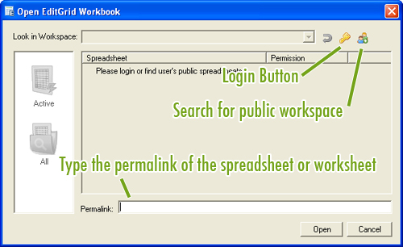
When you're not logged in and never searched for a public workspace

8.1 Open Public Workspace
Users can reference spreadsheets under other users' public workspace. To open a public workspace, click on the icon
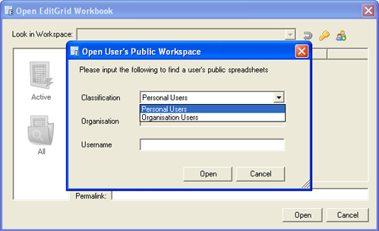
Select a classification and fill in the corresponding data to find that user's public workspace

8.2 After Logged in
When you've logged into your own workspace, the EditGrid File Browser will load spreadsheets from your workspace automatically. If you have a lot of spreadsheets in My Workspace, you can click on the "Active" icon on the left hand side to load only the active spreadsheets.
Note that if there aren't any Active spreadsheets, it doesn't mean there is no spreadsheet under the selected workspace. Be sure to also check All spreadsheets if you can't find spreadsheets under the Active category
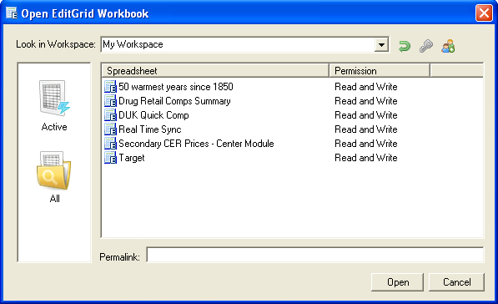
Show all spreadsheets under My Workspace

8.3 Switching Workspaces
If you logged in with an organisation account, you may have more than one workspace to look into. To switch over workspaces, simply click on the down arrow of the drop down menu at the top of the EditGrid File Browser, and select a workspace.
Public workspaces are listed on the mentioned drop down menu as well. Every time you open a public workspace, it will be stored on memory so you can reopen that workspace very easily by selecting it on the workspace menu.

8.4 Navigating over spreadsheets and worksheets
When you want to open a spreadsheet, simple select a spreadsheet then click "Open" or double click on the spreadsheet.
If you want to open a Worksheet inside a Spreadsheet, open a spreadsheet by double clicking it, or highlight it then click "Open". The included worksheets will be listed on the window

