Comment décoder les messages illisibles reçus via Spammotel ?
Solution 1 (utilisable par tout le monde) 1
Solution 2 (avec Thunderbird Header Tools Extension) 3

NOTA: inspirez vous des deux exemples donnés ici pour déterminer quelles sont les parties à supprimer (surlignées en jaune), qui peuvent varier selon le contenu de vos mails.

_________________________________________________________________________________________________

Solution 1 (utilisable par tout le monde)
Exemple de message reçu:
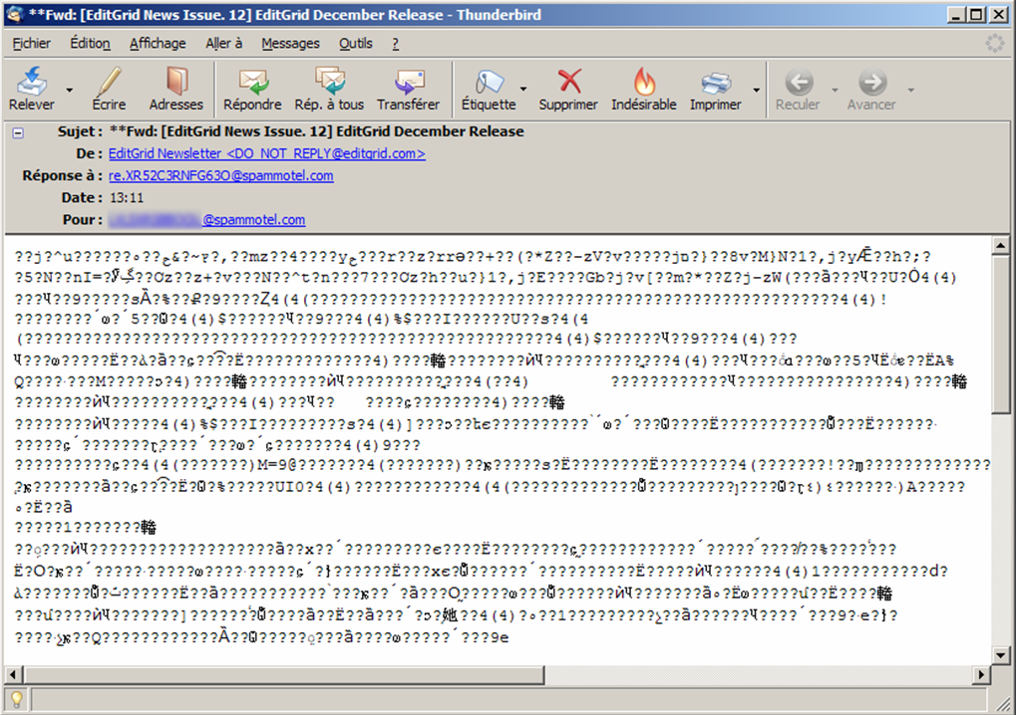

1) Afficher le code source du message, et l'enregistrer dans un fichier texte (dans Thunderbird: Affichage > Code source du message).
2) Supprimer de ce fichier texte tous les caractères liés à l'en-tête de Spammotel (surlignés en jaune ci-dessous):

From - Tue Dec 11 13:45:32 2007
X-Account-Key: account6
X-UIDL: 16627
X-Mozilla-Status: 0001
X-Mozilla-Status2: 00000000
X-Mozilla-Keys:
Return-Path: <re.XR52C3RNFG63O@spammotel.com>
Received: from spammotel.com (209.190.47.10) by mail.libertysurf.net (7.1.026)
id 474AE700012D29E4 for monnom@nospam.fr; Tue, 11 Dec 2007 13:39:26 +0100
Received: from hawk.computerwizards.com (smmsp@localhost [127.0.0.1])
by spammotel.com (8.13.8/8.13.8/Debian-3) with ESMTP id lBBCdP8t030629
for <monnom@nospam.fr>; Tue, 11 Dec 2007 07:39:25 -0500
Received: (from root@localhost)
by hawk.computerwizards.com (8.13.8/8.13.8/Submit) id lBBCdOIs030342
for monnom@nospam.fr; Tue, 11 Dec 2007 07:39:24 -0500
Old-Return-Path: <eismail+796983@event.com.hk>
Received: from event.com.hk ([203.86.167.7])
by spammotel.com (8.13.8/8.13.8/Debian-3) with ESMTP id lBBCBVF0025140
for <XYZXYZXYZXYZ@spammotel.com>; Tue, 11 Dec 2007 07:11:34 -0500
Date: Tue, 11 Dec 2007 07:11:34 -0500
Message-Id: <200712111211.lBBCBVF0025140@spammotel.com>
Old-Subject: [EditGrid News Issue. 12] EditGrid December Release
Old-Reply-To: cs@bidonspam.com
To: XYZXYZXYZXYZ@spammotel.com
From: "EditGrid Newsletter" <DO_NOT_REPLY@bidonspam.com>
Content-Type: multipart/alternative; boundary="1197372309.Baf1003171.11171";
charset="UTF-8"
Subject: **Fwd: [EditGrid News Issue. 12] EditGrid December Release
Reply-To: <re.XR52C3RNFG63O@spammotel.com>

--1197372309.Baf1003171.11171
Content-Type: text/plain; charset="UTF-8"
Content-Transfer-Encoding: base64

--------------Forwarded by SpamMotel--------------
--------------------------------------------------
--from "EditGrid Newsletter" <DO_NOT_REPLY@bidonspam.com>--
--reply cs@bidonspam.com--

Spam Motel address created on 2007-04-25 12:50:19
This Message received on Tue Dec 11 07:39:24 EST 2007
Last Message received on 2007-11-15 07:27:29

No. 349 Messages Forwarded: 9 Messages Received: 9

*** EditGrid ***

--XYZXYZXYZXYZ@spammotel.com--
--------------------------------------------------

RGVhciBFZGl0R3JpZCBVc2VyLA0KDQpFZGl0R3JpZCBOZXdzbGV0dGVyIChJc3N1ZSBOby4gMTIp
DQoNCi0tLS0tLS0tLS0tLS0tLS0tLS0tLS0tLS0tLS0tLS0tLS0tLS0tLS0tLS0tLS0tLS0tLS0t
LQ0KDQpIaWdobGlnaHRzIHRoaXMgTW9udGg6DQoNCkkuKSBFZGl0R3JpZCBOZXdzDQoNCklJLikg
UmVsZWFzZSBVcGRhdGVzDQoNCi0tLS0tLS0tLS0tLS0tLS0tLS0tLS0tLS0tLS0tLS0tLS0tLS0t
LS0tLS0tLS0tLS0tLS0tLQ0KDQpJLikgRWRpdEdyaWQgTmV3cw0KDQpFZGl0R3JpZCwgdGhlIG1v
c3QgcG9wdWxhciBzcHJlYWRzaGVldCBiZWhpbmQgR29vZ2xlIA0KaHR0cDovL2Jsb2cuZWRpdGdy
aWQuY29tL2FyY2hpdmVzLzM2NQ0KDQpFZGl0R3JpZCBhd2FyZGVkIHRoZSBNZXJpdCBBd2FyZCBh
dCBBUElDVEEgMjAwNyBpbiBTaW5nYXBvcmUgDQpodHRwOi8vYmxvZy5lZGl0Z3JpZC5jb20vYXJj
aGl2ZXMvMzU4DQogIA0KQmVjb21lIGFuIEVkaXRHcmlkIGZhbiBpbiBGYWNlYm9vaw0KaHR0cDov
L2Jsb2cuZWRpdGdyaWQuY29tL2FyY2hpdmVzLzM1MQ0KDQpFZGl0R3JpZCBCbG9nIHJlZGVzaWdu
ZWQgDQpodHRwOi8vYmxvZy5lZGl0Z3JpZC5jb20NCg0KSUkuKSBSZWxlYXNlIHVwZGF0ZXMNCg0K
V2Ugd2VyZSBxdWl0ZSBidXN5IGZpeGluZyBidWdzIHRoaXMgbW9udGgsIGJ1dCBkaWQgbWFuYWdl
IHRvIGdldCBzb21lIG5ldyBmZWF0dXJlcyBhbmQgaW1wcm92ZW1lbnRzIGluIHRoaXMgcmVsZWFz
ZS4gIA0KDQpOZXdseSBhZGRlZCBmZWF0dXJlczoNCg0KICAgICogIEpTT05QIHN1cHBvcnQNCiAg
ICAqICBKdXN0aWZpZWQgdGV4dCBhbGlnbm1lbnQgaW4gY2VsbHMNCiAgICAqICBIeXBlcmxpbmsg
ZW5oYW5jZW1lbnRzDQogICAgKiAgQWR2ZXJ0aXNlIG9uIHlvdXIgc3ByZWFkc2hlZXQgd2l0aCBJ
bWFnZSBVUkwgDQoNCkVuaGFuY2VtZW50czoNCg0KICAgICogIEFiaWxpdHkgdG8gc3BlY2lmeSBj
b2x1bW4gd2lkdGgvcm93IGhlaWdodA0KDQpQbGVhc2UgdmlzaXQgb3VyIENoYW5nIExvZyBodHRw
Oi8vd3d3LmVkaXRncmlkLmNvbS9jaGFuZ2Vsb2cvIGZvciBkZXRhaWxzIGFuZCBjb21wbGV0ZSBs
aXN0IG9mIGZlYXR1cmVzLCBlbmhhbmNlbWVudHMgYW5kIGJ1ZyBmaXhlcy4gIElmIHlvdSd2ZSBn
b3QgcXVlc3Rpb25zIG9uIGhvdyBhbnkgb2YgdGhlIG5ldyBmZWF0dXJlcyB3b3JrLCBkb24ndCBo
ZXNpdGF0ZSB0byBzZW5kIHVzIGFuIGVtYWlsIGF0IGNzQGVkaXRncmlkLmNvbS4NCg0KTGlrZXdp
c2UsIGlmIHlvdSB3b3VsZCBsaWtlIHRvIHZvaWNlIG91dCB5b3VyIGZlZWRiYWNrLCBzdWdnZXN0
aW9ucyBvciBpc3N1ZXMsIHNlbmQgdGhlbSB0byBjc0BlZGl0Z3JpZC5jb20gb3IgdmlzaXQgdGhl
IGZvcnVtIGF0IGh0dHA6Ly9mb3J1bS5lZGl0Z3JpZC5jb20uIFdlJ2QgbG92ZSB0byBoZWFyIHdo
YXQgb3VyIHVzZXJzIGFyZSBzYXlpbmcuDQoNCkRhdmlkIExlZSwgY28tZm91bmRlciBvZiBFZGl0
R3JpZCwgaXMgaW4gTmV3IFlvcmsgQ2l0eSBub3cgdW50aWwgVGh1cnNkYXksIERlY2VtYmVyIDEz
dGgsIDIwMDcuICBGb3IgYWxsIHRoZSB1c2VycyBpbiBOWUMgd2hvJ2QgbGlrZSB0byB0YWxrIHNw
cmVhZHNoZWV0cyB3aXRoIGhpbSBvciBzaW1wbHkgd2FudCB0byB3aXNoIGhpbSBhIGhhcHB5IGhv
bGlkYXkgaW4gcGVyc29uLCB5b3UgY2FuIGZpbmQgaGltIGJ5IGVtYWlsaW5nIGhpbSBhdCBkYXZp
ZEBlZGl0Z3JpZC5jb20uDQoNCkxhc3RseSwgdGhlIGhvbGlkYXkgc2Vhc29uIGlzIHVwb24gdXMg
YWdhaW4sIHdoaWNoIG1lYW5zIDIwMDcgaXMgY29taW5nIHRvIGEgY2xvc2UgYW5kIGl0IGhhcyBi
ZWVuIGEgZnVuIGFuZCBldmVudGZ1bCB5ZWFyIGZvciBFZGl0R3JpZCBhbmQgd2UgaG9wZSB5b3Vy
IGV4cGVyaWVuY2Ugd2l0aCB1cyBoYXMgYWxzbyBiZWVuIHRoZSBzYW1lLiAgS2VlcCB5b3VyIGV5
ZXMgb3BlbiBhbmQgbG9vayBmb3IgYmV0dGVyIHRoaW5ncyB0byBjb21lIGZyb20gdXMgaW4gMjAw
OC4gIA0KDQpFZGl0R3JpZCB3aXNoZXMgZXZlcnlvbmUgaGFwcHkgaG9saWRheXMhDQoNClRoYW5r
cyBhZ2FpbiBmb3Igc3VwcG9ydGluZyBFZGl0R3JpZCBhbmQgc2VlIHlvdSBpbiAyMDA4Lg0KDQpU
aGUgRWRpdEdyaWQgVGVhbQ0KDQotLS0tLS0tLS0tLS0tLS0tLS0tLS0tLS0tLS0tLS0tLS0tLS0t
LS0tLS0tLS0tLS0tLS0tLS0tLS0tLS0tLS0tLS0tLS0tLS0tLS0tDQpZb3UgYXJlIHJlY2Vpdmlu
ZyB0aGlzIG5ld3NsZXR0ZXIgYmVjYXVzZSB5b3UgaGF2ZSBjaG9zZW4gdG8gcmVjZWl2ZSB1cGRh
dGVzIGZyb20gdXMuICANCg0KSWYgeW91IHdpc2ggdG8gdW5zdWJzY3JpYmUgb3VyIG5ld3NsZXR0
ZXIgc3Vic2NyaXB0aW9uLCBwbGVhc2UgcmVwbHkgdG8gdGhpcyBlbWFpbCB3aXRoIHRoZSBzdWJq
ZWN0ICJ1bnN1YnNjcmliZSIuDQo=

--1197372309.Baf1003171.11171--

3) Décoder ce fichier texte. Avec TotalCommander: sélectionner le fichier > Fichier > Décoder fichier

4) et voila le résultat:

Dear EditGrid User,

EditGrid Newsletter (Issue No. 12)

------------------------------------------------------

Highlights this Month:

I.) EditGrid News

II.) Release Updates

------------------------------------------------------

I.) EditGrid News

EditGrid, the most popular spreadsheet behind Google
http://blog.editgrid.com/archives/365

EditGrid awarded the Merit Award at APICTA 2007 in Singapore
http://blog.editgrid.com/archives/358

Become an EditGrid fan in Facebook
http://blog.editgrid.com/archives/351

EditGrid Blog redesigned
http://blog.editgrid.com

II.) Release updates

We were quite busy fixing bugs this month, but did manage to get some new features and improvements in this release.

Newly added features:

* JSONP support
* Justified text alignment in cells
* Hyperlink enhancements
* Advertise on your spreadsheet with Image URL

Enhancements:

* Ability to specify column width/row height

Please visit our Chang Log http://www.editgrid.com/changelog/ for details and complete list of features, enhancements and bug fixes. If you've got questions on how any of the new features work, don't hesitate to send us an email at cs@bidonspam.com.

Likewise, if you would like to voice out your feedback, suggestions or issues, send them to cs@bidonspam.com or visit the forum at http://forum.editgrid.com. We'd love to hear what our users are saying.

David Lee, co-founder of EditGrid, is in New York City now until Thursday, December 13th, 2007. For all the users in NYC who'd like to talk spreadsheets with him or simply want to wish him a happy holiday in person, you can find him by emailing him at david@bidonspam.com.

Lastly, the holiday season is upon us again, which means 2007 is coming to a close and it has been a fun and eventful year for EditGrid and we hope your experience with us has also been the same. Keep your eyes open and look for better things to come from us in 2008.

EditGrid wishes everyone happy holidays!

Thanks again for supporting EditGrid and see you in 2008.

The EditGrid Team

----------------------------------------------------------------------------
You are receiving this newsletter because you have chosen to receive updates from us.

If you wish to unsubscribe our newsletter subscription, please reply to this email with the subject "unsubscribe".

Solution 2 (avec Thunderbird Header Tools Extension)
Cette extension permet non seulement de modifier les en-têtes des emails, mais aussi d'éditer et de modifier le contenu des emails.

Exemple de message reçu:
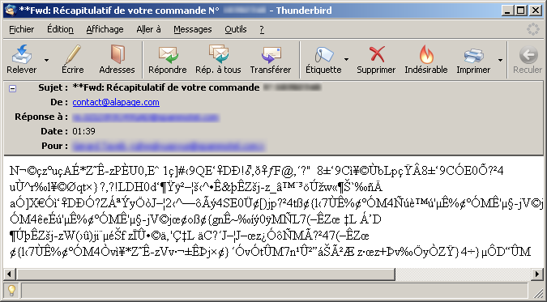

1) Clic droit sur le sujet du message dans TB, puis "Change Header Details" (Nota: dans Thunderbird 3: sélectionner le message par clic gauche sur le sujet du message dans TB, puis menu Messages > Change Header Details).
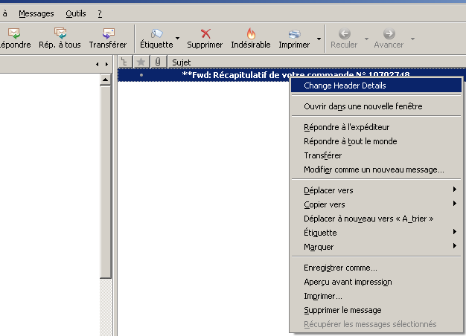

2) Cliquer sur "Edit Full Source":
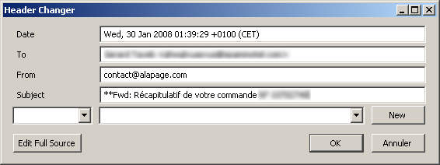

3) Supprimer tous les caractères liés à l'en-tête de Spammotel (surlignés en jaune ci-dessous):

From dummy@dummy Sun Jul 11 00:00:00 1999
X-Account-Key: account6
X-UIDL: 18584
X-Mozilla-Status: 0000
X-Mozilla-Status2: 00000000
X-Mozilla-Keys:
Return-Path: <re.0ZI2XR9O49GAD@spammotel.com>
Received: from spammotel.com (209.190.47.10) by mail.libertysurf.net (7.1.026)
id 4790824B00FA790D for monnom@nospam.fr; Wed, 30 Jan 2008 15:32:14 +0100
Received: from hawk.computerwizards.com (smmsp@localhost [127.0.0.1])
by spammotel.com (8.13.8/8.13.8/Debian-3) with ESMTP id m0UEWCpl005316
for <monnom@nospam.fr>; Wed, 30 Jan 2008 09:32:12 -0500
Received: (from root@localhost)
by hawk.computerwizards.com (8.13.8/8.13.8/Submit) id m0UEWCs9005186
for monnom@nospam.fr; Wed, 30 Jan 2008 09:32:12 -0500
Old-Return-Path: <apache@alapage.com>
Received: from front.alapage.com (front.alapage.com [193.253.149.24])
by spammotel.com (8.13.8/8.13.8/Debian-3) with ESMTP id m0U0daKs002264
for <nimportequoi@spammotel.com>; Tue, 29 Jan 2008 19:39:38 -0500
Received: by localhost (Postfix, from userid 48)
id 5A3DD1F9E6; Wed, 30 Jan 2008 01:39:29 +0100 (CET)
To: Moi <nimportequoi@spammotel.com>
Old-Subject: Récapitulatif de votre commande N° 10702748
From: contact@alapage.com
MIME-Version: 1.0
Content-Type: multipart/mixed;
boundary="----=_001"
Message-Id: <20080130003929.5A3DD1F9E6@localhost>
Date: Wed, 30 Jan 2008 01:39:29 +0100 (CET)
Subject: **Fwd: Récapitulatif de votre commande N° 10702748
Reply-To: <re.0ZI2XR9O49GAD@spammotel.com>

This is a multi-part message in MIME format.

------=_001
Content-Type: multipart/related;
boundary="----=_002"

------=_002
Content-Type: multipart/alternative;
boundary="----=_003"

------=_003
Content-Type: text/plain; charset="iso-8859-1"
Content-Transfer-Encoding: quoted-printable

--------------Forwarded by SpamMotel--------------
--------------------------------------------------
--from contact@alapage.com--
--reply contact@alapage.com--

Spam Motel address created on 2004-12-04 10:20:03
This Message received on Wed Jan 30 09:32:11 EST 2008
Last Message received on 2007-06-05 16:35:23

No. 55 Messages Forwarded: 5 Messages Received: 5

*** alapage ***

--nimportequoi@spammotel.com--
--------------------------------------------------

HTML only!

------=_003
Content-Type: text/html; charset="iso-8859-1"
Content-Transfer-Encoding: base64

<!This Banner Added By SpamMotel>
<DIV>
<TABLE WIDTH="510" BGCOLOR="#FFFFFF" BORDER="0" CELLPADDING="0" CELLSPACING="0">
<COLGROUP span="2" WIDTH="255"></COLGROUP><TR>
<TD VALIGN="middle" colspan="2" HEIGHT="130" ALIGN="CENTER">
<IMG SRC="http://spammotel.com/spammotel/images/bannertop.gif" HEIGHT="129" WIDTH="507" BORDER="0" ALT="Forwarded by SpamMotel">
</TD></TR><TR>
<TD colspan="2" ALIGN="RIGHT"><font size=2 color="#000000">--from <font color="#0000FF">contact@alapage.com</font>-- &nbsp</font>
<br><font size=2 color="#000000">--reply <font color="#0000FF">contact@alapage.com</font>-- &nbsp</font>
</TD></TR><TR>
<TD colspan="2" HEIGHT="20"><IMG SRC="http://spammotel.com/spammotel/images/blank.gif" HEIGHT="20" BORDER="0" ALT="SpamSpacer">
</TD></TR><TR>
<TD ALIGN="LEFT" colspan="2"><font size=2 color="#000000">&nbsp; Spam Motel address created on 2004-12-04 10:20:03<br>
&nbsp; This Message received on Wed Jan 30 09:32:11 EST 2008<br>
&nbsp; Last Message received on 2007-06-05 16:35:23
</TD></TR><TR>
<TD colspan="2" HEIGHT="20"><IMG SRC="http://spammotel.com/spammotel/images/blank.gif" HEIGHT="20" BORDER="0" ALT="SpamSpacer">
</TD></TR><TR>
<TD ALIGN="LEFT" colspan="2" ALIGN="CENTER"><font size=2 color="#000000"> &nbsp No. 55 &nbsp &nbsp Messages Forwarded: 5 &nbsp &nbsp Messages Received: 5</font>
</TD></TR><TR>
<TD colspan="2" HEIGHT="20"><IMG SRC="http://spammotel.com/spammotel/images/blank.gif" HEIGHT="20" BORDER="0" ALT="SpamSpacer">
</TD></TR><TR>
<TD colspan="2" ALIGN="CENTER"><font size=2 color="#000000">*** <font color="#0000FF"> alapage</font> ***</font>
</TD></TR><TR>
<TD colspan="2" HEIGHT="20"><IMG SRC="http://spammotel.com/spammotel/images/blank.gif" HEIGHT="20" BORDER="0" ALT="SpamSpacer">
</TD></TR><TR>
<TD ALIGN="LEFT">&nbsp;</TD>
<TD ALIGN="RIGHT"><font size=2 color="#000000">--<font color="#0000FF">nimportequoi@spammotel.com</font>-- &nbsp</font>
</TD></TR><TR>
<TD VALIGN="middle" HEIGHT="20" colspan="2" ALIGN="CENTER" ><IMG SRC="http://spammotel.com/spammotel/images/bannerbottom.gif" HEIGHT="26" WIDTH="500" BORDER="0" ALT="End of SpamMotel Banner">
</TD></TR></TABLE>
</DIV>
<!End Banner Added By SpamMotel>

DQo8IURPQ1RZUEUgSFRNTCBQVUJMSUMgIi0vL1czQy8vRFREIEhUTUwgNC4wMSBGcmFtZXNldC8v
RU4iICJodHRwOi8vd3d3LnczLm9yZy9UUi9odG1sNC9mcmFtZXNldC5kdGQiPg0KPGh0bWw+DQo8
aGVhZD4NCgk8dGl0bGU+QWxhcGFnZS5jb20gLSBWb3RyZSBjb21tYW5kZSAtIFBhaWVtZW50PC90
aXRsZT4NCiAgICA8bWV0YSBodHRwLWVxdWl2PSJjb250ZW50LXR5cGUiIGNvbnRlbnQ9InRleHQv
aHRtbDsgY2hhcnNldD1pc28tODg1OS0xIiAvPg0KDQo8L2hlYWQ+DQo8Ym9keSBzdHlsZT0iZm9u
..... j'en ai coupé un peu, ce n'est pas passionnant! ....
eCAzcHggMHB4OyI+PGEgc3R5bGU9ImNvbG9yOiM1MjVFNjk7IiBocmVmPSIvLS9TZWxlY3Rpb25P
Y2Nhc2lvbi8/dHlwZT1QRE0mcmVmPWhvbWUmcG9zPTEmaWQ9MjY0NTEyMDE2NTI5ODImZG9ubmVl
X2FwcGVsPUNMSUJJIj5PY2Nhc2lvbnM8L2E+PC9saT4KCTwvdWw+CjwvZGl2Pg0KDQo8L2Rpdj4N
CjwhLS0gL3BhZ2UgLS0+DQo8L2NlbnRlcj4NCjwvYm9keT4NCjwvaHRtbD4NCg==

------=_003--

------=_002--

------=_001--

3) et hop, c'est fini:
