Resonant cavity antennas

Giacomo Benelli ⁽¹⁾, Stefan Enoch ⁽¹⁾, Gérard Tayeb ⁽¹⁾, Patrick Vincent ⁽¹⁾,
Jean-Michel Geffrin ⁽¹⁾, Pierre Sabouroux ⁽¹⁾,
Hervé Legay ⁽²⁾

⁽¹⁾ Institut Fresnel, UMR CNRS 6133
Campus de Saint-Jérôme, case 161, 13397 Marseille Cedex 20, France
giacomo.benelli@fresnel.fr, stefan.enoch@fresnel.fr, gerard.tayeb@fresnel.fr,
patrick.vincent@fresnel.fr, jean-michel.geffrin@fresnel.fr

⁽²⁾ Alcatel Space
26 Av. J.F. Champolion, 31037 Toulouse Cedex, France
Herve.Legay@space.alcatel.fr

INTRODUCTION

New designs of directive antennas using EBG materials or metamaterials have been the subject of several recent studies [1-6]. In the framework of a collaboration between Alcatel Space Industries and the Fresnel Institute, several solutions for the design of directive and compact antennas in the Ku band have been investigated. The common features of these antennas are: they are made of metallic grids lying on a ground plane, and only one feeding device (monopole or patch) is used.

In previous studies, we have designed high gain antennas using a Perot-Fabry like resonator or using the ultra-refractive properties of metamaterials [1]. In that case, the edge length of the antennas was equal to 11 λ. We were not especially looking for very high efficiencies, and we obtained experimentally 40% for the Perot-Fabry like antenna, and 25% for the metamaterial antenna. For these designs, we can get a frequency bandwidth of about 1%.

In the present paper, we report on our work on smaller antennas with 2.8 λ edge intended for a Direct Radiating Array element use. We look for high surface efficiencies (90% is targeted), and a frequency bandwidth of 5%.

TWO-DIMENSIONAL OPTIMIZATION

In order to find proper parameters for the structure, we start with a 2D modeling. The structure is depicted in Fig. 1. It is made of a ground plane and metallic vertical walls. This cavity is closed by a metallic grid. It is fed by a strip current distribution that simulates the patch in the actual 3D structure.

Fig. 1: sketch of the 2D model of the cavity antenna

Since the aim is to get a surface efficiency , the 3D directivity is given by , which gives for the principal radiation lobe a half-power beamwidth . It means that the two-dimensional targeted directivity is .
The grid is made of a periodical arrangement of infinitely conducting strips, with period d fixed, and the strips width is w. The thickness of the strips is equal to 0.14 mm, which corresponds to the thickness of the metallic plate used to etch the grid in the experiment. In the numerical optimization, the parameters are the grid position (distance h to the ground plane) and the width of the strips w. The cost function used for the optimization is aimed to give a directivity as close as possible to a given one in a given frequency range. This range is chosen to 5% = ±2.5%, centered on 14 GHz. We have used d = 5.8 mm, and in that case the result of the optimization is w = 2.1 mm, and h = 10.9 mm. Figure 2 shows how the 2D directivity behaves with respect to the frequency. The two vertical lines delimit the 5% frequency range. With this structure, it does not seem possible to reach a directivity of 16.7. Figure 3 gives the radiation pattern in a 10% frequency range. In this 2D case, the emitted field is obviously linearly polarized. Figure 3 shows that the secondary lobes decreases as the frequency decreases.

Fig. 2: 2D directivity of a 2D structure.

Fig. 3: Emission pattern in dB scale: map (left) and cuts for 6 frequencies (right).

THREE-DIMENSIONAL MODELING

The 3D structure has the same parameters as the 2D structure of the previous section. In that case, the grid is made with crossed strips, keeping the same values for d and w. It is fed by a square patch with edge 8.6 mm. Figure 4 shows the normalized radiation pattern: for each frequency, the maximum of the co-polarization is normalized to 0 dB, and the cross-polarization level is normalized to the maximum of the co-polarization level. Compared to Fig. 3, the frequency range of Fig. 4 is extended towards the lower frequencies, since it appears that the behavior of the experimental antenna is better in this range. The behavior in the H plane and for co-polarization is quite similar to that observed in the 2D simulation. However, high levels of cross-polarization appear.

No cross polarization in the E plane

Fig. 4: Modeled normalized emission patterns in dB scale.

EXPERIMENTAL RESULTS

An antenna has been built using copper. The grid is chemically etched from a copper sheet with 0.14 mm thickness. This antenna is shown on Fig. 5. The measurements has been done in our anechoic chamber. In this chamber, we have the possibility to make measurements on a sphere with radius 1.8 m and centered on the antenna. Figure 6 presents the measured radiation pattern. There is a good agreement with the modeled data of Fig. 4. The main differences come from the cross-polarization level, and specially in the E plane. They are due to some dissymmetry, probably caused by a misalignment of the structure. It appears that some resonant frequencies of the cavity enhance the cross- polarization radiation. It is already observed on the modeled results of Fig. 4. Some new frequencies appear on the experimental results of Fig. 6. This can be explained by the fact that selection rules based on symmetry forbid the excitation of some of the modes, while in the experiments, the lack of symmetry allows these excitations.
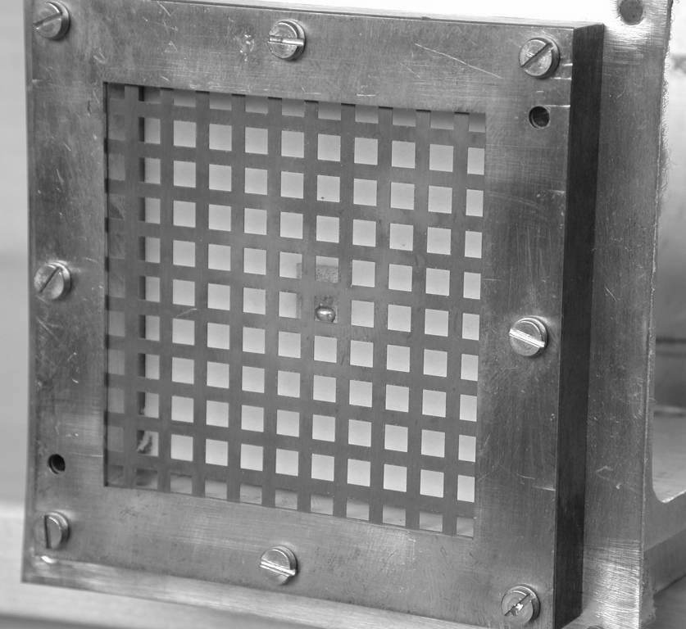

Fig. 5: Image of the antenna.

Fig. 6: Experimental normalized emission patterns in dB scale.

CROSS-POLARIZATION REDUCTION

According to the previous results, it seemed useful to study a more symmetrical excitation. As a first attempt, we have simulated the same structure, but excited by a slot centered on the antenna, and with 6 × 1 mm aperture. In this case, there is no cross-polarization in both E and H planes. Figure 7 shows the co-polar levels in the H and E planes. In this case, the cross-polar vanishes. Note that the frequency range is chosen in order to show the useful range of frequencies, and is different from the range of the previous graphs. Note that in a range of about 1 GHz, the half-power beam widths stay between ±8.5° and ±12°.

Fig. 7: Modeled normalized emission patterns with a slot excitation.

CONCLUSION

The design of small antennas with high surface efficiencies seems to be feasible, as shown by our last simulations. Of course, we have to make experimental validations of these last results.

In this first step, we have shown the feasibility of the concept, but we have not yet tried to optimize all the parameters of the structure. In particular, the design of the grid plays an important role. According to recent results [2], the use of grids with nonuniform parameters has to be considered, and will probably be a way to enhance the properties of these structures.

REFERENCES

[1] S. Enoch, G. Tayeb, P. Sabouroux, N. Guérin, and P. Vincent, "A Metamaterial for Directive Emission," Phys. Rev. Lett. 89 , 213902 (2002).
[2] R. Sauleau, P. Coquet, T. Matsui and J.P. Daniel, "A new concept of focusing antennas using plane-parallel Fabry-Perot cavities with nonuniform mirrors," IEEE Trans. Ant. Prop. 51, p.3171-3175 (2003).
[3] M. Thèvenot, C. Cheype, A. Reineix, and B. Jecko, "Directive Photonic-Bandgap Antennas," IEEE Trans. MTT 47, p.2115-2122 (1999).
[4] P. de Maagt, R. Gonzalo, Y.C. Vardaxoglou, J.M. Baracco, "Electromagnetic bandgap antennas and components for microwave and (sub)millimeter wave applications", IEEE Trans. Ant. Prop. 51, p.2667-2677 (2003).
[5] H. Boutayeb, K. Mahdjoubi, A.C. Tarot, "Antenna inside PBG and Fabry-Perot cavities", JINA 2002, Vol. 2, p.141-144 (2002).
[6] R. Biswas, E. Ozbay, B. Temelkuran, M. Bayindir, M.M. Sigalas, K.M. Ho, "Exceptionally directional sources with photonic-bandgap crystals," J. Opt. Soc. Am. B 18, p.1684-1689 (2001).

